The Description of Annotator Tool V1

This tool is to build exemplars automatically on Google flights and booking.com.

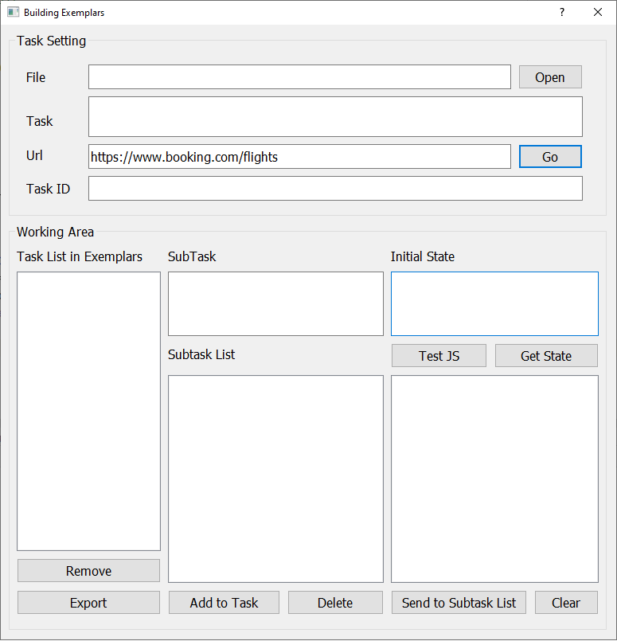

1. How to Work: Step by Step
2. Click “Open” button to open the exemplar file (*.json)

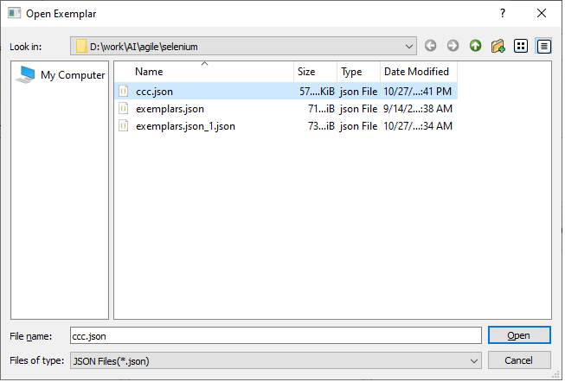

Once file is selected, then chosen file’s exemplar content is loaded in this tool. You will see all tasks in the list.

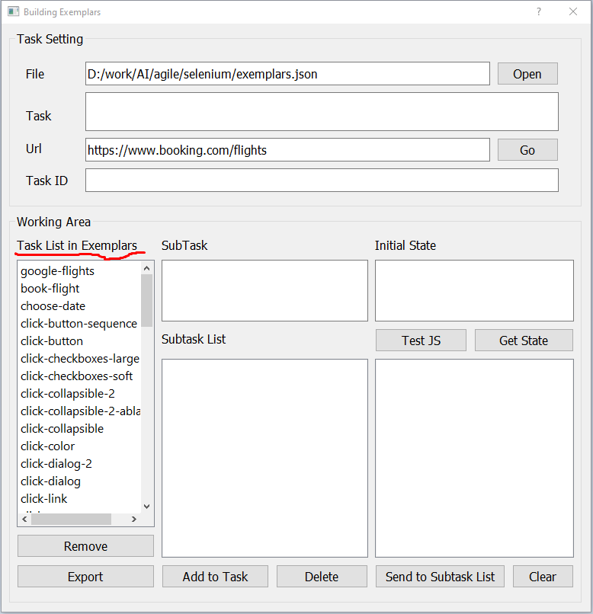

1. If you double click any task in the task list, then that task’s task title, task ID, subtasks are loaded. Also… if you double click subtask in subtask list, then subtask’s content is loaded.

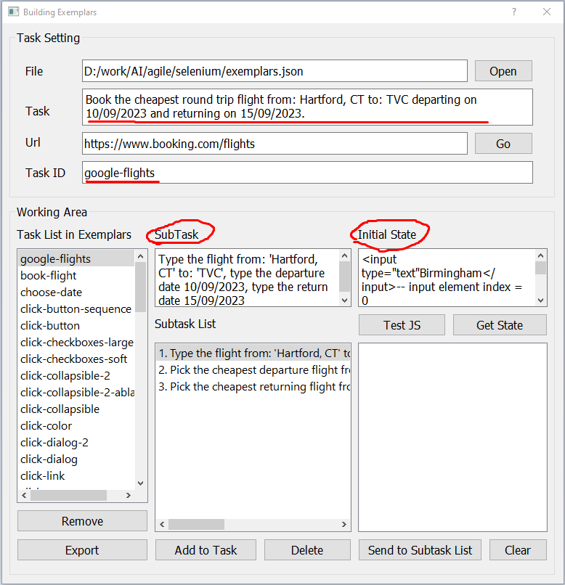

1. Click “Go” button to open the selenium browser and navigate to url.

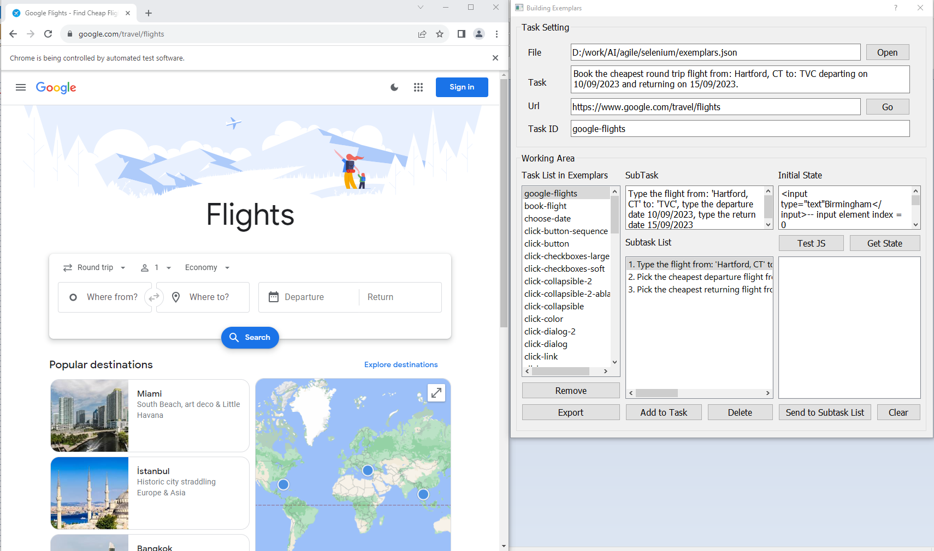

Once browser is opened and url is fully loaded, then click, type events on this browser are captured and stored in our tool.

1. And… click “Get State” button to get the initial state of the webpage. Initial State will be filled in the textbox.
2. Click or Type something on the selenium browser, then you can see those events are captured and stored in our tool. By clicking “Clear” button, you can clear captured events.
3. Once you think the actions of a subtask are completed, then please click “Send to Subtask List” to add actions to the chosen subtask.

You will see message Yes/No/Cancel. If you click “Yes”, then new subtask is created, if you click “No”, chosen subtask is updated. Then subtask list would be updated as follows:

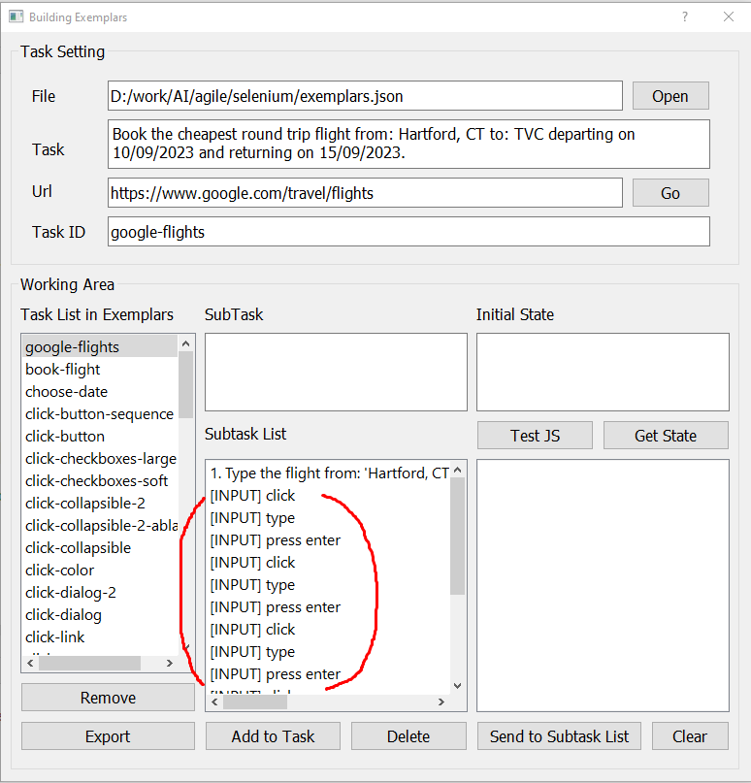

1. In this way, we can edit or create subtasks.
2. You will see “Delete” button. By clicking this button, you can delete any subtask.
3. Once you think all subtasks are ready, then by clicking “Add to Task” button, you can add created subtasks to chosen Task ID. If Task ID is new, new task is created and added to task list. If Task ID is an existing task, then subtask content are added to existing task.

Selenium Browser will be closed.

1. By clicking “Remove” button, you can remove task from task list.
2. You can click “Export” button to generate exemplar file.
3. Warning
4. **Before doing anything on selenium browser, I recommend clicking “Test JS” button. This button will check if browser and our tool connected each other. After clicking this button, “Successful” message is displayed, then it means everything is ok!**

This is needed when page is submitted in selenium browser. Our tool catches all events fired on selenium browser, by attaching javascript code to the browser. But… when a form is submitted, then page is reloaded, so javascript code will be not working. To prevent this problem, that button is needed.

For example, on booking.com, when clicking “Search” button, page is reloaded, and unless you click this “Test JS” button, not working.

So I want you to click “Test JS” button at the beginning of editing subtask.

1. **Sometimes, click events wouldn’t be captured and stored in our tool. In this case, I recommend to type text, instead of clicking.**

For example, I will explain with datepicker on google.com/travel/flights.

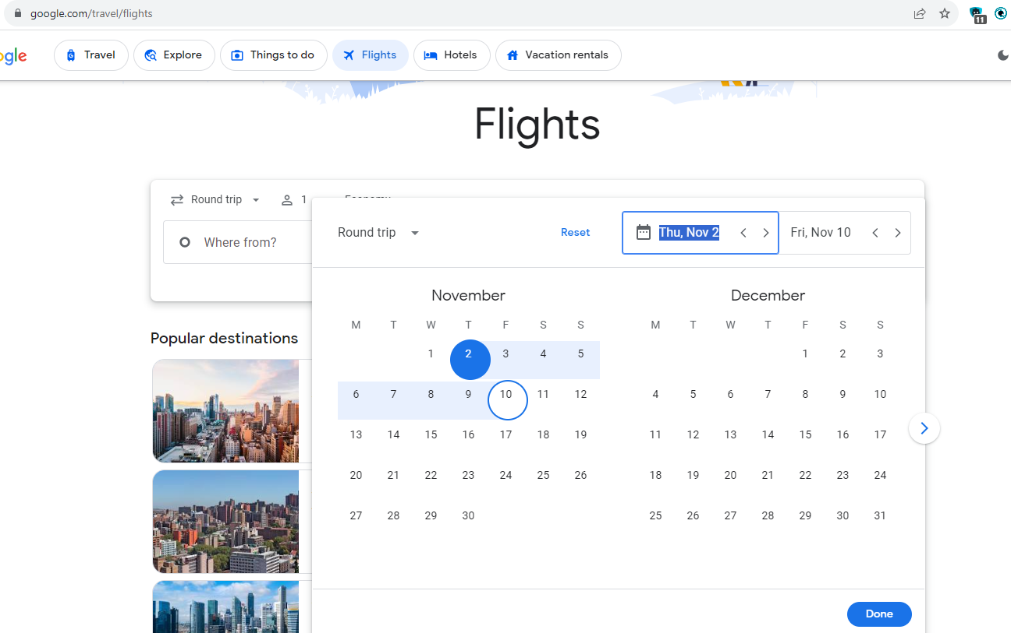

As you know, we can pick dates as above. But… our tool doesn’t capture these events, because… this html element is just <div>.

So… In such cases, I recommend to type dates in the textbox, instead of clicking, like below image.

